William Sanchez

SER 401

September 28, 2022

**Steps on how to start a Dart Flutter project.**

Below are step by step instructions on how to create a base Flutter application project in VS Code.

1. Download the Flutter SDK if you need it from [here](https://docs.flutter.dev/development/tools/sdk/releases)
2. If it doesn’t exist create the root folder where the project files will live.
3. While in VS Code, go to File –> Open Folder, open the root folder.
4. While in VS Code hold CTRL + Shift + P and type in Flutter
5. Click in Flutter: New Project – > Application.
6. Choose the folder where the application folder will go.
7. Name the application.
8. Flutter will automate the creation of files.

Before running Flutter for the first time:

1. While in VS Code hold CTRL + Shift + P and type in Flutter Doctor.
2. Flutter Doctor will tell you if any dependencies are missing and how to install them.

The result should look something like this:

Steps to install Android Tablet Simulator.

1. Install Android Studio from [here](https://developer.android.com/studio)
2. After Android studio is installed click on Tools – Device manager and follow steps to [Create an AVD](https://developer.android.com/studio/run/managing-avds) of a Tablet device.
   1. These were my selections:
   2. 
   3. Chart, treemap chart

      Description automatically generated
3. In VS Code hold CTRL + Shift + P and type in Start and you should see the Emulator listed

1. End result will be a tablet simulator.

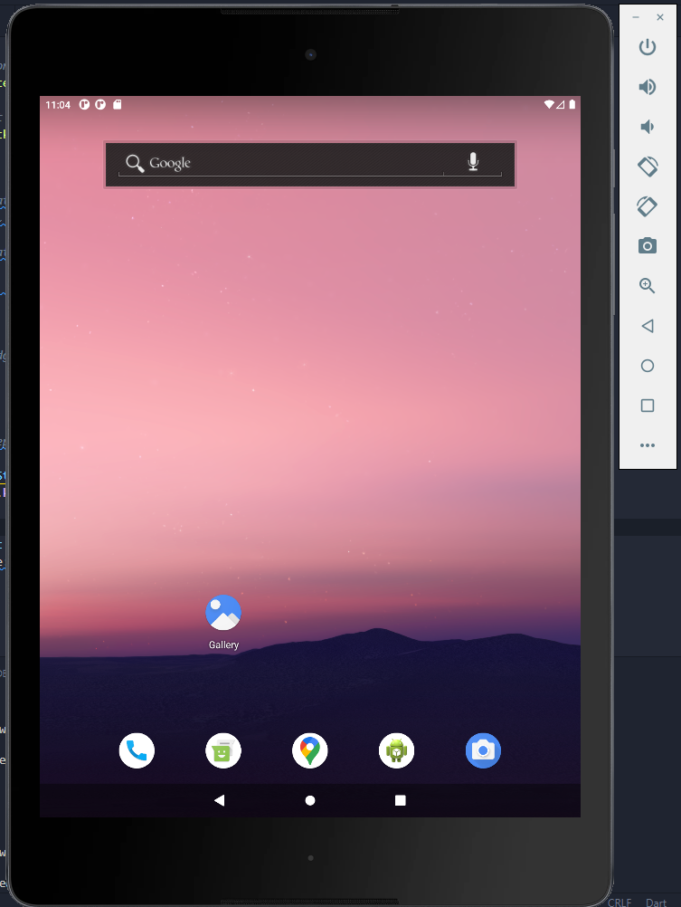

1. To run your project in the terminal type in **flutter run**.